IEDC Project
MODULAR PAPER PUNCH

Proposed by: Mentor:
Mr. B.SAKTHIKIRAN Mr. R.L.SANKAR LAL. M.E., (Ph.D).,
Reg. No: 111711114125 Asst. Professor (Gr-II)
Final Year B.E-MECH., Dept. of Mechanical Engg.,
R.M.K. ENGINEERING COLLEGE R.M.K. ENGINEERING COLLEGE

ABSTRACT:
Nowadays we expect our office tools to be more compact and multi-functional. The proposed project is a typical paper punch, which emphasizes primarily on reducing the size and weight of the commonly used conventional ‘Single hole paper punch’. The uniqueness of this modular punch is its compactness, ease of handling, ease of use, multi-functional and cost effective. This modular paper punch is designed based on the principle of compound lever mechanism as in nail clippers, which uses minimum pinch force exerted by thumb to piece a hole, rather than plier mechanism, and hence the entire design is becoming more compact. A punching head attached at the upper jaw is forced through a die on the lower jaw through a lever arm, which is gripped in the hand. As the mild pressure is applied to the lever arm by thumb, it punches the papers.
As an additional feature, a yarn scissor is proposed to be attached to the modular paper punch, riveted at the other end. A yarn scissor is generally used for cutting the threads, and used to cut the edge of the cloth to initiate tear. This arrangement may also be utilized even for hard cutting such as clipping the excessive length of the plastic spiral driven through a set of punched holes in soft spiral binding and any more other applications.

INTRODUCTION
A hole punch or hole maker or paper puncher is a common office tool that is used to create holes in sheets of paper, often for the purpose of collecting the sheets in a binder or folder. The origins of the hole punch date back to Germany via Matthias Theel, where two early patents for a device designed to "punch holes in paper" have since been discovered. Friedrich Soennecken made his patent on November 14, 1886. Nowadays based on the purpose there are many the number of holes to be made the paper punches are classified as single hole paper punch, Double hole paper punch and ranging up to 7-hole paper punch. But the most commonly used paper punches are single hole and double hole type.
Single hole punches are often used to punch tickets, small bunch of papers. A single hole punch have a shorter reach and no choice of hole shape. Though the single hole paper punch is smaller than the multi hole paper punch it is not so handy. The single hole paper punch is usually works on pliers mechanism ( class-1 lever).
The most common standard for the dimensions and location of filing holes punched in paper is International Standard ISO 838. Two holes with a diameter of 6±0.5 mm are punched into the paper. The centers of these holes are 80±0.5 mm apart and have a distance of 12±1 mm to the nearest edge of the paper. The holes are located symmetrically in relation to the axis of the sheet or document.

EXISTING PAPER PUNCHER
A typical hole punch, whether a single or multiple hole punch, has a long lever which is used to push a bladed cylinder straight through a number of sheets of paper. As the vertical travel distance of the cylinder is only a few millimeters, it can be positioned within a centimeter of the lever fulcrum. For low volume hole punches, the resulting lever need not be more than 8 cm for sufficient force.
The typical mechanism used in single hole paper punch is ‘Pliers mechanism’. The Pliers mechanism is a lever of Class-1 type. A lever is a machine consisting of a beam or rigid rod pivoted at a fixed hinge, or fulcrum. Levers are classified by the relative positions of the fulcrum and the input and output forces. It is common to call the input force the effort and the output force the load or the resistance. Therefore there are 3 classes of lever. The Class-1 leaver is featured with Fulcrum in the middle and the effort is applied on one side of the fulcrum and the resistance on the other side, for example, cutting pliers or a pair of scissors. Mechanical advantage may be greater or less than 1. The ratio of the output force to the input force is called mechanical advantage.
The Single hole paper punch in common use works similar to cutting pliers, where the hinge pin connecting the two levers act as a fulcrum. The effort is applied on both levers in one side. Due to this effort the punch pierces through the bunch of paper.
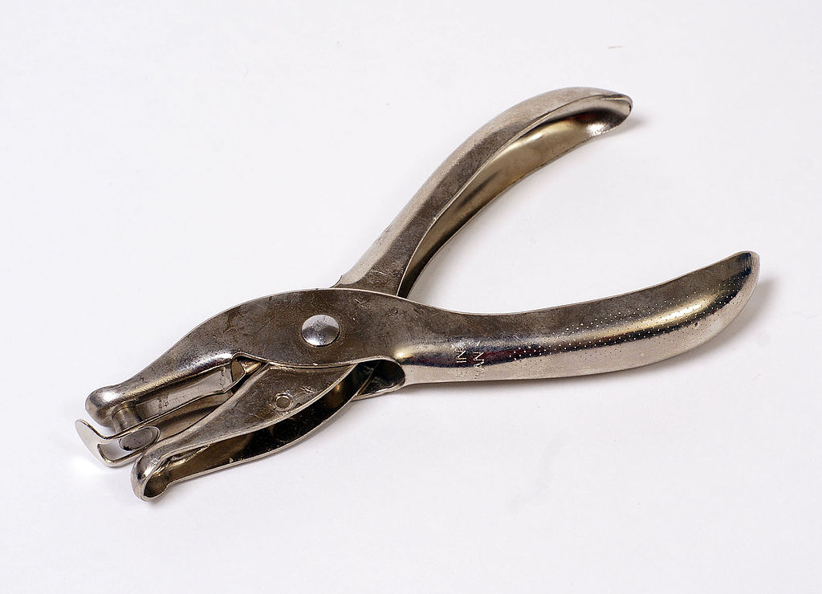

The main limitation of existing single hole paper punch is its size and lack of multi-functionality. Due to the wide open levers the dimensions of these paper punches are more.

MODULAR PAPER PUNCH
Nowadays we are using number of office tools for performing variety of tasks. We also expect those office tools to be more compact and portable. Moreover we want such tools to perform more than one task at a time i.e multifunctional. Thus this proposed project concentrates on compacting and enhancing one of such most commonly used office tool- ‘The single hole Paper Punch’. The proposed project emphasize primarily on reducing the size and weight of the common paper punch. Moreover the secondary concern is to add an additional feature for cutting the plastic spiral or thread fastened through the punched holes.
The minimization of size is to be achieved by making use of compound lever mechanism as used in nail clippers, instead of Pliers mechanism. The thread cutting feature is proposed to have yarn scissors integrated with the compound lever mechanism. The compound lever mechanism is a combination of two classes of lever mechanism. The combination of class-2 and class-3 mechanisms are to be used for this project. The class 2 mechanism have resistance in the middle. The effort is applied on one side of the resistance and the fulcrum is located on the other side, for example, a wheelbarrow, a nutcracker, a bottle opener or the brake pedal of a car. Mechanical advantage is always greater than 1.

In the class 3 lever the effort in the middle. The resistance is on one side of the effort and the fulcrum is located on the other side, for example, a pair of tweezers or the human mandible. Mechanical advantage is always less than 1.

The Modular Paper Punch on the basis of compound lever mechanism. In this arrangement, the class 2 lever is used for application of effort (hand pressure) and punching is done by class 3 lever. The working is similar to that of the conventional nail clipper. Thus the following diagram shows the forces acting on the nail clipper (compound lever mechanism).
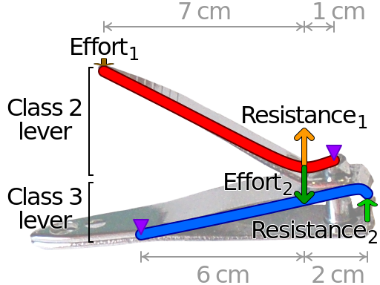
There are 3 main parts in the modular paper punch. They are
- Base
- Lever
- Yarn scissors
The base of nail clipper is made of stainless steel. It has two plates ( upper and lower plate) connected to each other at the rear. They are inclined to each other at an angle of 3 degree. The proposed model has punching head in near the tip of upper plate and a punch die of same size at lower plate, replacing the usual cutting head.
The leverage part or the lever arm is connected to the base plates both upper and lower by a bolt. The lever arm is connected to the bolt using a hinged pin, which enables the free swing of arm. This hinged pin permits the arm swing the arm 43 degree about the base. The bolt is provided to allow leverage to rotate 360 degree about the bolt.
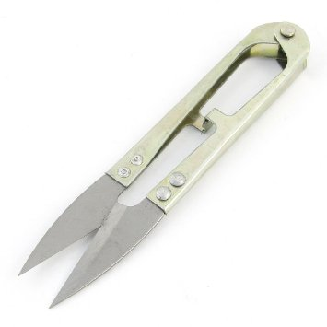
The yarn scissors works on the principle of class 3 mechanism. It has two arms, with blades in each arm on one side and the other side being hinged. The required force for cutting is provided by hand against the tension of closed coil helical spring on the hinged side. In this proposal the yarn scissors is attached to the modular paper punch by riveting at the its end.
The punching head is forced through a die on lower jaw by lever mechanism, which is gripped in the hand. As the hand applies pressure to the handle, it punches the papers. Due to the effort on the class 2 (lever arm or handle) lever a resistance is developed in opposite direction which forces the upper plate to lower. The upper plate which acts as a class 3 lever attains force and develops a resistance at the punch head. Once the lever arm is released, due to spring action of upper plate, it comes back to original position.
DESIGN OF MODULAR PAPER PUNCH
Any product which is being developed and that are about to be developed, the following development steps follows. It starts with identification of problem and it is a cyclic process.

Regarding the modular paper punch the identification of problem, ideas for solving the problem, principle involved are already discussed. The design of Modular Paper punch has been done in Creo Parametric. Creo is a family or suite of design software supporting product design for discrete manufacturers and is developed by PTC. Creo runs on Microsoft Windows and provides apps for 2D design, 3D CAD parametric feature solid modeling, 3D direct modeling, Finite Element Analysis and simulation, schematic design, technical illustrations, and viewing and visualization. PTC Creo Parametric provides the broadest range of powerful yet flexible 3D CAD capabilities to accelerate the product development process. In the designing phase, individual part is sketched and developed. Then the parts are assembled in Creo Parametric Assembly module.

Parts of Modular paper punch designed in Creo

1.Base of paper punch
2.Lever arm

3. Bolt 4. Rivert
5. Yarn scissors arm
6. Blade of scissors

7. Subassembly of yarn scissor
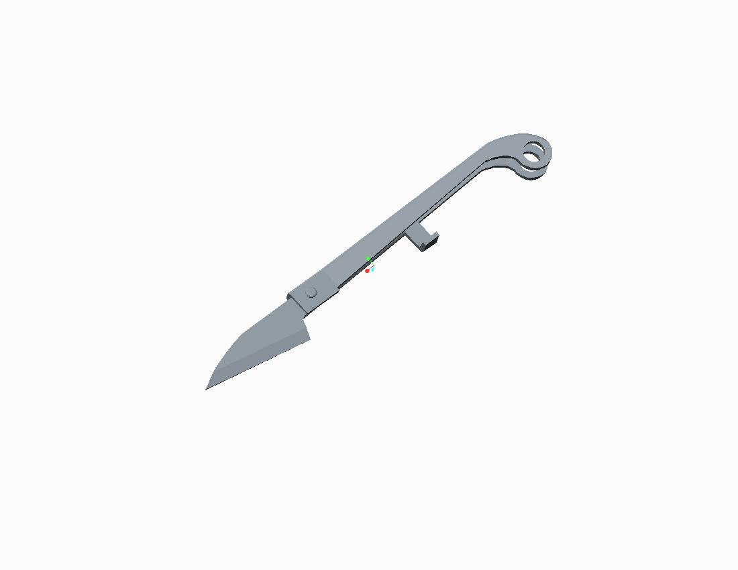
8.Yarn scissors
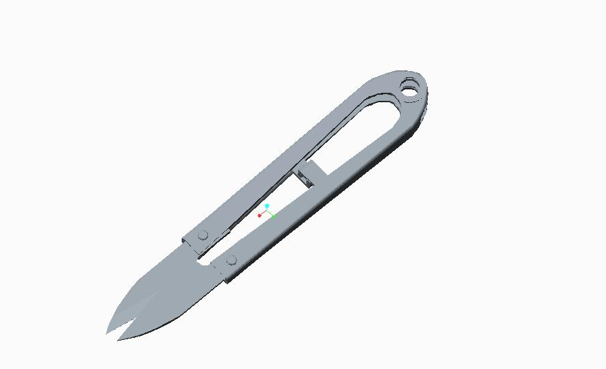
Major dimensions of Modular Paper punch
S.no | Modular Paper punch | Dimension (mm)
1 | Total length | 82
2 | Maximum width | 14
3 | Maximum height | 10
4 | Length of lever arm | 53
5 | Width of lever arm | 9
6 | Thickness of lever arm | 3.5
7 | Diameter of pivot pin | 4
8 | Height of | 13
9 | Thickness of metal in base | 1
10 | Diameter of rivert | 2.5
11 | Length of yarn scissors | 50
12 | Maximum height of scissors | 4
13 | Maximum width of scissors | 11
14 | Thickness of blade | 1
15 | Length of wedge | 15
16 | Diameter of punch | 6
17 | Clearance between punch & die | 2.5

Various views of Assembled Modular paper punch

Side views of Modular Paper punch

Standard view
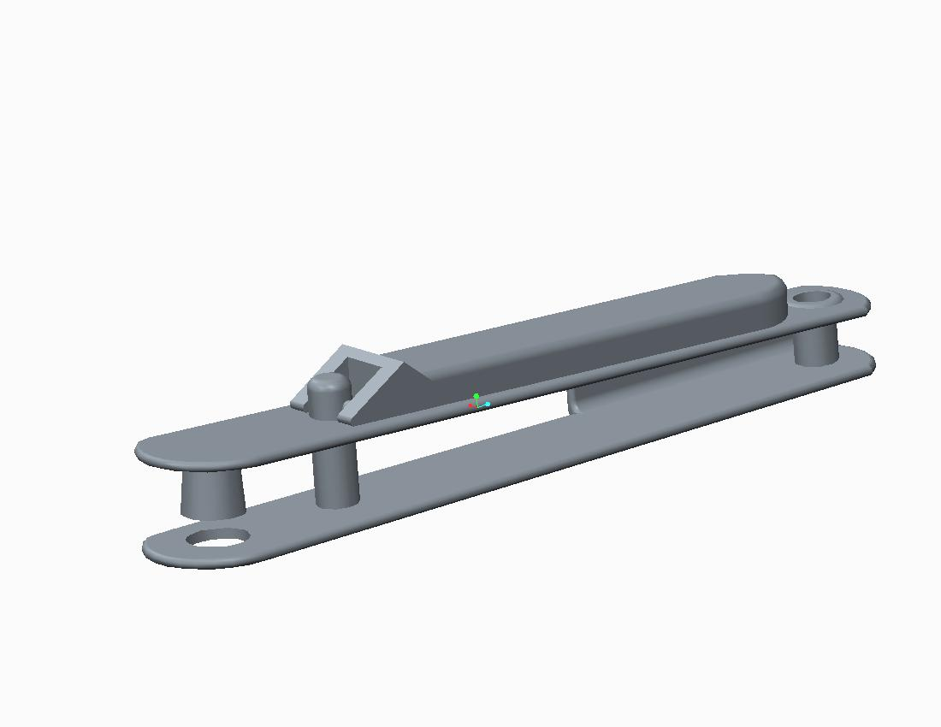
Top view
Side views of Modular Paper punch with Yarn scissors

Top view
Standard view
DESIGN CALCULLATIONS

DESIGN PROCEDURE
- STEP 1: Defining specifications of paper.
- STEP 2: Defining specifications of punch hole.
- STEP 3: Calculation of force required on punch head.
- STEP 4: Calculation of force on upper plate.
- STEP 5: Calculation of force on tip of lever.
- STEP 6: Analysis of Average lateral pinch force.
- STEP 7: Checking safety of design
Required lever force < Avg Lateral pinch force

STEP 1: Defining specifications of paper
- Thickness of paper = 0.2 mm (max)
- Shear strength of paper = 300 N/mm.sq
- No. of papers to be punched = 10

STEP 2: Defining specifications of punch hole.
- Hole diameter = ¼” = 6.25 mm
- Punch head clearance = No. of paper * thickness
= 2 mm

STEP 3: Calculation of force required on punch head.
- The force required at the punch head is the shear force of n no. of papers.
- Shear force = shear strength * shear area
shear force = shear strength of paper * nπDt
= 300* 100 * π * 6.25 * 0.18*10^-3
Force required = 11.775 N

STEP 4: Calculation of force on upper plate.
Class 2 lever
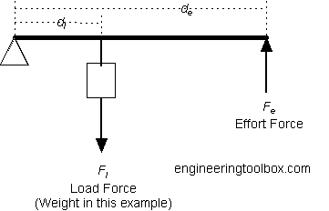

According to momentum equation,
F_{e} X d_{e} = F_{l} X d_{l}
F_{e} X 60 = 11.775 X 80
F_{e} = 15.7 N

Mechanical advantage upper plate = F_{e} / F_{l}
M.A = 0.75 < 1
Thus condition of class 3 lever is satisfied
STEP 5: Calculation of force on tip of lever.
Here effort in class 3 lever is the load in class 2 lever
According to momentum equation,
F_{e} X d_{e} = F_{l} X d_{l}
F_{e} X 80 = 15.7 X 10
F_{e} = 2 N

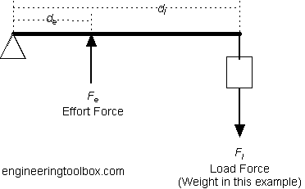

Mechanical advantage upper plate = F_{e} / F_{l}
M.A = 8 > 1
Thus condition of class 3 lever is satisfied

STEP 6: Analysis of Average lateral pinch force.
- The finger force applied in handle of compound lever mechanism is called LATERAL PINCH FORCE
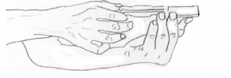

- Average right hand lateral pinch force = 44.14 N
- Average left hand lateral pinch force = 41.79 N
- Values of lateral pinch force referred from “Validation of hand function assessment in leprosy” published in Rev Saúde Pública

STEP 7: Checking safety of design
Safe design = Required lever arm force < Avg Lateral pinch force
2 N < 44.14 N
Therefore DESIGN IS SAFE

